# State of the IOTC Bigeye Operating Models for Management Procedure evaluation March 2021

Dale Kolody (dale.kolody@csiro.au)

Paavo Jumppanen

CSIRO, Australia

## Introduction

This document provides a brief description of the most recent state of the Indian Ocean bigeye tuna Operating Models (OMs) used for Management Procedure (MP) evaluation (IOTC-2021-WPM12(MSE)-04, IOTC-2021-TCMP04-08), including the reference set *OMrefB.20.1,* and 6 robustness tests requested by the WPTT and WPM. The documentation for the latest version of the MSE software, technical documentation, and series of project reports is publicly available from github <https://github.com/pjumppanen/niMSE-IO-BET-YFT/>. The iterative and sometimes circuitous decision process undertaken by the IOTC technical working groups and analysts to reach the current state of the OM are not described here. These may be found in various IOTC working papers, information papers and meeting reports, along with various model results and diagnostics that were used to guide the OM development process.

The reference set OM, *OMrefB20.1,* is described in more detail in Kolody et al. (2020). It was endorsed by the WPTT (2020), and has not changed since then.

## Conditioning Software

This version of the OM is an ensemble of models conditioned using the *Stock Synthesis* (SS) assessment software version SS3.24z (e.g. Methot and Wetzel 2013).

## Projection Software

The projection software is custom built, available from <https://github.com/pjumppanen/niMSE-IO-BET-YFT/>. The population dynamics equations conform to fairly standard assumptions, and are fully documented in the technical reference (also on github).

## OM structure

The various models in the OM ensemble are derived from the most recent bigeye stock assessment (Fu 2019). Key differences from the assessment include: i) aggregation of the 4 temperate season-specific CPUE series, into a single series (each independently renormalized by the respective series mean over a common period of non-missing observations), ii) recruitment deviations for the most recent 12 quarters were constrained to the stock recruitment relationship (though lognormal noise was introduced into the initial age structure for the MSE projections)m and iii) some parameter bounds were relaxed if the bound seemed likely to be influential to the model outcome. Key structural assumptions include:

* 4 regions (Figure 1) with age-dependent movement
* Quarterly dynamics (implemented with calendar quarters defined as SS model-years)
* 15 fisheries (Table 1)
* Beverton-Holt recruitment dynamics
* Parameter estimation objective function includes
  + Standardized longline CPUE (1 series per region)
    - Only the Hooks Between Floats option was used for the standardized tropical LL CPUE series (the cluster analysis of the previous OM iteration was not included because the CPUE group did not update that series)
  + Size composition data
  + Tags (excluded in some OM scenarios)
  + Penalties on recruitment deviations from stock recruit relationship and mean spatial distribution
  + Diffuse priors on all estimated parameters
* Estimated parameters:
  + Fishery selectivity (stationary, various functional forms, parameters shared among some fleets)
  + Longline catchability - regional scaling factors are used to scale relative density to relative abundance among regions
  + Virgin recruitment
  + Recruitment deviations from the Beverton-Holt stock-recruit relationship, and recruitment spatial partitioning among tropical regions (no spatial deviations over time).
  + Juvenile and adult movement rates
  + Initial fishing mortality
* Other fixed parameters and assumptions are either adopted as in the Fu (2019) assessment, or the grid structure described below.

## Reference Set Grid OMgridB20.1

* Model structural and parameter uncertainty is introduced to the OM by combining the alternative assumption options listed in Table 2.
* Only the point estimates (maximum posterior density) for parameters and initial states are used in the OM.
* A fractional-factorial experimental design was used to select a subset of 72 models for fitting, which would allow the estimation of all main effects in the context of a GLM (the full factorial grid with all interactions would require 432 models).
* In recognition that the IOTC bigeye assessment model parameter estimates can be sensitive to initial starting conditions, minimization was repeated from randomly jittered starting conditions until either (i) successful minimization was achieved 3 times (maximum gradient of the objective function with respect to the estimated parameters <0.01) or (ii) 10 attempts at minimization were completed.

## OM Reference Set *OMrefB20.1 (subset of OMgridB20.1)*

* Within an individual model configuration, the replicate with the lowest objective function value (from the jittered minimizations) was retained (initially). The best fit models were subsequently rejected from the reference grid if:
  + Minimization unsuccessful (max. grad. >0.01) – in this iteration, there were no failures following the repeated, jittered minimization process
  + The SS3 Catch Penalty (i.e. model struggles to remove the observed catch, which is assumed to be related to the pessimistic retrospective patterns). This potentially could indicate a serious problem, but was ignored in this iteration.
* All retained models were subject to a qualitative comparison of simple diagnostics to identify outlier behaviour or polymodal stock status inferences (no obvious problems were noted). The four most extreme models (highest and lowest depletion and productivity) were visually examined in more detail, without obvious evidence for blatant model failure (e.g. systematic lack of fit).
* Each SS model is assigned a plausibility weighting. To date, models have only been assigned a weighting of 0 or 1, such that all retained models are uniformly weighted. *OMrefB20.1* consists of 500 models randomly sampled (with replacement) from the grid of retained models.
* Key projection assumptions are summarized in Table 3.

## References

Fu, D. 2019. Preliminary Indian Ocean bigeye tuna stock assessment 1950-2018 (Stock Synthesis). IOTC-2019-WPTT21-61

Kolody, D, Jumppanen, P, Day J. 2020. Indian Ocean Bigeye Tuna Management Procedure Evaluation Update March 2020. Report prepared for the Indian Ocean Tuna Commission Informal Management Strategy Evaluation workshop 2020. IOTC-2020-WPM11-11

Methot, R.D., Wetzel, C.R. 2013. Stock synthesis: A biological and statistical framework for fish stock assessment and fishery management. *Fisheries Research 142 (2013)* 86–99.



Figure 1. Spatial structure for the bigeye tuna OM (figure from Fu 2019).

Table 1. Fishery definitions in the BET 2016 assessment (from Fu 2019).

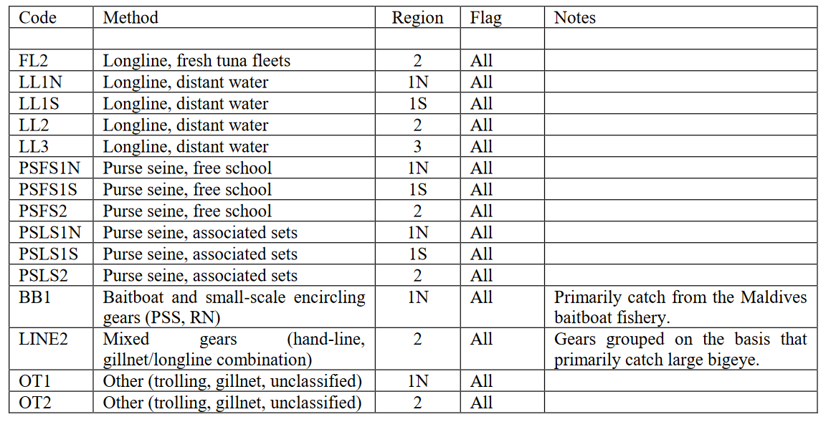

Table 2. Assumptions in OMrefB20.1 Stock Synthesis conditioning. Assumptions not listed are adopted from the Fu (2019) assessment (bold indicates the reference case assumptions in the assessment), or described in the text above.

|  |  |
| --- | --- |
| Abbreviation | Definition |
| h70  h80  h90 | Stock-recruit function (*h* = steepness)  Beverton-Holt, *h* = 0.7  **Beverton-Holt, *h* = 0.8**  Beverton-Holt, *h* = 0.9 |
| M10  M08  M06 | Natural mortality multiplier relative to reference case M vector  **1.0**  0.8  0.6 |
| t0001  t01  t10 | Tag recapture data weighting (tag composition and negative binomial)  λ = 0.001  λ = 0.1  **λ = 1.0** |
| q0  q1 | Assumed longline CPUE catchability trend (compounded)  **0% per annum**  1% per annum |
| iR1  iR2 | longline CPUE Regional-scaling factors  preferred estimate from Hoyle (2018) – 7994_m8 alternate from Hoyle (2018) – 8000_m8 |
| SL  SD | Longline fishery selectivity  **Stationary, logistic, shared among areas**  Stationary, double-normal (potentially dome-shaped), shared among areas |
| ESS10  CLRW | Size composition input Effective Sample Sizes (ESS)  **ESS = 10, all fisheries**  ESS = One iteration of re-weighting from reference case model, applied at the level of the individual observation, capped at 100. |

Table 3. OM Projection assumptions in the bigeye reference set and robustness sets. Reference set values not listed are identical to the model-specific conditioning assumptions/estimates. Robustness case values are identical to the reference set except as noted in Table 4.

|  |  |  |
| --- | --- | --- |
| OM | Projection assumption | Value |
| OMrefB20.1 | Reference set OM |  |
|  | Initial population error CV  (a = age in quarters) | 0.6exp(-0.1a) |
|  | Recruitment deviation penalty  Recruitment deviation lag(1) auto-correlation  (these are annual values, but they are parameterized by the quarterly quarterly equivalents) | *max(σR* = 0.42, SS estimate)  *max(ρR* = 0.21, SS estimate) |
|  | CPUE observation error  CPUE observation error lag(1) auto-correlation  (implemented annually) | *max(σI* = 0.2, SS estimate)  *max(ρI* = 0.5, SS estimate) |
|  | Multinomial Catch-at-length sample size  (all fisheries) | 100 |
|  | Selectivity stationary for all fisheries |  |
|  | Quota Implementation error | CV = 0 |
|  | First MP quota year | 2022 |
|  | Bridging catches 2019-2021 | 81 Kt  (2018 Observed Catch) |
|  | MP data lag  (i.e. data up to and including 2020 would inform the 2023 quota) | 2 years |
|  | Quota allocation (average observed over) | 2017-2018 |
|  | Number of stochastic realizations | 500 |

Table 4. Robustness tests requested for BET by the WPTT (2020). Conditioning, and other assumptions not listed are identical to the reference set (Table 3).

|  |  |  |
| --- | --- | --- |
|  | Robustness tests (other features as reference set) |  |
|  | 1. Increased Longline CPUE error variance   σI = 0.3, *ρI* = 0.5 |  |
|  | 1. 10% overcatch, accurately reported |  |
|  | 1. 10% overcatch, unreported |  |
|  | 1. 10% overcatch, 5% reported, 5% not reported |  |
|  | 1. 8 consecutive quarter recruitment shock (55% of average, near start of projections) |  |
|  | 1. 3% per year LL catchability trend   (not in SS conditioning; projections only) |  |